TCSS 478/588 Final Group Project Version 2, Winter 2026

Logistics and Grading
Your final project will be graded out of a total of 40 points, and will contribute 40% towards your final grade as stated in the syllabus.

All work will be submitted via Canvas. Similar to the homework, late submissions within 24-hour of the due date will be accepted with a 20% penalty. You can work in groups of 3-4 students for this project. By default, all students in the same team will receive the same grade. But I reserve the right to adjust grades of individual students based on the documented division of labor and the optional peer review form.

Please note that the required tasks and evaluation rubric for TCSS 478 and TCSS 588 students are different. Your team will be responsible for TCSS 588 tasks and evaluated using the TCSS 588 rubric if at least one member of your team is in TCSS 588.

Project overview
In class and asynchronous materials, we have discussed high-throughput technologies, such as bulk and single cell RNA sequencing, that can measure gene expression levels of thousands or tens of thousands of genes simultaneously. We also introduced bioinformatics resources and software tools that can be used to analyze biomedical data. The goal of this final project is to contribute to the preparation of a crowdsourcing challenge organized by the Jackson Lab (JAX) Data Analysis and Validation (DAV) center of the NIH MorPhiC program (https://morphic.bio/ ).

Credits: This crowdsourcing challenge is developed by Drs. Olivier Poirionand and Brian White at the Jackson Laboratory for Genomic Medicine.

Motivation: The MorPhiC program aims to advance the understanding of human genes by generating high throughput data investigating the consequences of inactivating genes. Different experimental strategies, such as knockout (KO), are being employed to inactivate selected genes. For more detailed description of these experimental strategies, please refer to https://morphic.bio/methods/#gene-knock-out-ko. In particular, DAVs are interested in inferring gene regulatory networks (GRN) to better understand the impact of transcription factors (TF) on other genes. Transcription factors (TF) are essential proteins that control gene activity by turning genes on or off, ensuring proper cell function, growth, and development. For more background information, please refer to the slides (link) and corresponding Panopto video posted on Feb 19 on Canvas Announcements.

Overall Description: This crowd sourcing challenge aims to predict the effect of KO of TF relative to wild type (WT). Our overarching assumption is that TF activity should be repressed following KO, and that the magnitude of the (WT - KO) shift in TF activity can be used to rank methods for computing TF regulons. We can also evaluate the performance of GRN inference methods by computing the concordance between predicted and observed shifts.

Training Data: We will be using WT multiome and WT and TF/KO scRNA-seq data from the manuscript Single-cell brain organoid screening identified developmental defects in autism by Li, et al. The authors developed an experimental system for perturbing genes and then profiling the resulting perturbed (and WT!) cells using scRNA-seq. They call their system CHOOSE – CRISPR-human organoids-single-cell RNA sequencing. They apply it to 36 high-risk autism spectrum disorder genes, including 14 TFs, within 8 cell types arising during neuronal development. CRISPR-Cas9 is an enzyme that occurs naturally in the bacterial immune system and has the ability to cut DNA. It is localized to an individual target gene by a guide RNA (gRNA) that is complementary to that target’s DNA. Once bound to DNA, the Cas9 nuclease cuts the DNA, thus disrupting the gene function. The experiment is a “screen” – it utilizes a pool of gRNAs targeting the 36 genes. These are delivered to cells via a “lentiviral” vector, each of which both activates (“induces”) the Cas9 machinery and provides a pair of gRNAs targeting a single gene. The experiment uses a low vector infection rate with the aim of introducing at most a single pair of gRNAs per cell. scRNA-seq then provides a readout of gRNAs within the cell, which allows us to infer which gene (if any) was targeted in the cell. This screening approach is scalable and efficient. On the other hand, it can not guarantee that the gene was actually perturbed (despite the presence of the targeting gRNA) nor can it guarantee that both copies of the gene (on autosomal chromosomes) are disrupted – that is, the induced mutation may be hetero- rather than homo-zygous. Partly motivated by these concerns, we suggest evaluating your approach on a small subset of TF targets and cell types (as described in Evaluation metrics below).

We are only providing the expression component of the WT multiome data. Those data should be used to develop your approach. They are in the CHOOSE-multiome-expr folder of the Data folder on Drive, with metadata in CHOOSE-multiome-wt-metadata.csv and the expression data matrix in CHOOSE-multiome-wt-log-norm.csv.gz. Each row of the metadata corresponds to a cell, with its cell id the row name. These cell ids are the column names of the data matrix. The cell type is provided in the celltype_jf column. The data are log-normalized – i.e., we applied NormalizeData(normalization.method = “LogNormalize”, scale.factor=10000) which divides the gene (or “feature”) count of each cell by the total counts for that cell, multiplies it by 10,000, and finally adds one and natural log transforms (log1p). We suggest using fread from the data.table R package for reading large expression matrices.

Once you have developed your approach, you can apply the evaluation metric (see below) to the WT and TF KO scRNA-seq data to see how it performs. Those data are in the CHOOSE-scRNA-seq subfolder of the Data folder, with metadata in CHOOSE-sc-wt-and-tf-metadata.csv and the expression data matrix in CHOOSE-sc-wt-and-tf-log-norm.csv.gz. The metadata and data are formatted and normalized as the mulitome data above, with the one important exception that these data include TF KOs, which are indicated in the gRNA_perturb column of the metadata. gRNA_perturb is CTRL for WT cells and otherwise is the gene symbol name of the KO’ed TF.

Baseline method: GRNBoost2
GRNBoost2 (described in this manuscript) is a more efficient and robust implementation of GRNBoost. However, the conceptual approach is similar and best described in the original manuscript here. GRNBoost2 applies gradient boosting machine (GBM) regression to learn a relationship between a (potential target) gene and all input TFs. More specifically, the expression of input TFs is used to predict the expression of each target gene. The weight of each TF in a gene’s regression model is reported as its (non-negative) importance. We use the python-based arboreto implementation of GRNBoost2. We postprocess the importance outputs to compute a p-value (as the upper tail of the normal cumulative distribution function centered at 0 with standard deviation computed from cell type- and TF-specific importances). We label putative TF target interactions as significant if they are above four standard deviations from the mean.

We are providing GRNBoost2 results inferred from the CHOOSE multiome data within the morphic-mini-challenge GitHub repo, specifically within the file postprocessed-grnboost2-all-tfs-celltypes-global-var-genes.csv.gz. Each row lists a putative TF target. Amongst other columns, the cell type is in cell.type, the transcription factor gene symbol is in TF, the target gene symbol is in target, the predicted mode of regulation (MoR) is in score, and whether that score passes a (GRNBoost2-specific) significance threshold is in significant. MoR (a termed used by our evaluation metric) is between -1 and 1, with the absolute value indicating the strength of the TF target interaction (higher absolute values imply stronger interactions) and the sign indicating the direction of regulation (with positive values indicating TF induction/positive regulation of the target and negative values indicating TF repression/negative regulation of the target).

Evaluation metrics: VIPER
Our evaluation will be based on VIPER (virtual inference of protein activity by enriched regulon analysis), as described in this manuscript. VIPER attempts to quantify the activity of a TF protein through the mRNA expression of its putative target genes. We compute a VIPER TF activity score for each WT cell and for each cell in which that TF is perturbed. We assume that the TF activity of WT cells will be larger than that of TF KO cells. We further assume that the magnitude of this shift between WT and TF KO cells increases with the accuracy of the set of TF target genes. As such, we evaluate TF target prediction methods (including GRNs like GRNBoost2) based on the magnitude of the shifts calculated from their inferences. We quantify the magnitude of the shift by using a one-tailed Wilcoxon test comparing the distribution of TF scores between WT and TF KO cells. We provide code to do this in the score.viper function (in apply-viper-evaluation.R). That script demonstrates how to apply score.viper to GRNBoost2 results derived from the CHOOSE dataset. It generates a plot (here) showing WT and TF KO distributions for six TF/cell type pairs, which includes the Wilcoxon p-value. Note that only one pair (TF BCL11A in cell type ctx_npc) is significant. This is the most reliable pair, and we recommend you focus on it during your testing. The five other pairs may not have sufficient signal for any method to detect. That said, if your method can do so it may be especially likely to generalize to other datasets. All six TF/cell type pairs are in CHOOSE-tf-to-analyze-metadata.csv.

Note that the final evaluation will be performed using a held-out dataset (of a different biological system with different cell types and with a different set of perturbed TFs). As such, your method should not be overfit to the WT and TF KO CHOOSE dataset provided.

VIPER is subtle. I find the methodological description in the original manuscript quite terse. In its full generality, VIPER assigns a putative TF target both a (non-negative) likelihood and a (signed) MoR. We set the likelihood to one for simplicity. It also attempts to account for shared targets across TFs via a pleotropy correction. This is useful when attempting to rank the relative activity of TFs. However, that is not relevant to our goal. As such, we do not apply that correction.

My understanding is based on supplementing that by reading the source code. We are using run_viper from the decoupleR R package. This is a wrapper around the original viper function in the viper R package from the Califano lab. And the heart of the logic is in the aREA function (here). Note that VIPER has been applied to different molecular readouts – including log fold changes from differential expression analyses. We apply it to normalized expression values. Given this application and at an abstract level, within each cell (or sample) VIPER ranks genes based on their expression value – with lowly expressed genes having the lowest rank (i.e., near one). For a putative set of TF targets, it then looks for an enrichment of targets at either or both of the extreme ends of the rank — this is the so-called 2-tail test. A TF target will score well in the 2-tail test if it is repressed (low/negative GRN prediction score) and has low rank or if it is induced (high/positive GRN prediction score) and has high rank. VIPER performs a second “1-tail” test – here the cell’s genes are re-ranked such that those with extreme (low or high) expression values have highest rank and those with moderate expression have low rank. VIPER finally performs a “3-tail” test which combines the 1- and 2-tail tests. For each gene, the 1- and 2-tail gene scores are weighted according to the gene target’s mode of regulation (MoR). As explained above, MoR is between -1 (highly repressed by the TF) and +1 (highly induced by the TF). These weighted combinations are then summed across all genes to yield a final enrichment score (ES) that quantifies the activity of the TF; its sign is that of the sum of the 1-tailed scores. For both the 1- and 2-tail tests, ranks are converted to scores by quantile normalizing them (to the normal distribution), such that low ranks (near 1) have low scores (near the left tail of the normal distribution cumulative density function) and high ranks have high scores (near the right tail of the cumulative density function).

I want to note a few apparent inconsistencies that have troubled me. Fig 1c of the original VIPER manuscript shows the method schematically. For example, the top of Fig 1c depicts an active TF “R1”, with arrows corresponding to predicted targets. Arrows are colored blue for predicted repressed/down regulated targets and red for predicted induced/up regulated targets. Arrows pointing up from R1 show their rank in the 1-tail test (labeled |GES| for Gene Expression Signature); whereas arrows pointing down from R1 show their rank in the 2-tail test (labeled GES). The 2-tail schematic is intuitive – it shows that predicted positively regulated targets (in red) have extreme high rank in the 2-tail test (first of two bars labeled GES) and negative regulated targets (in blue) have extreme low rank – upregulated targets and downregulated targets are at their respective extreme ends of the expression spectrum, as we would hope. Both the high and low ends contribute to high scores, because the quantile normalized ranks are weighted by the signed MoR. Hence, repressed targets (with negative MoR) that are ranked low (and have negative quantile normalized scores) will make a positive contribution to the score. This logic depends on weighting by the signed MoR, as the code does. The methods section of the manuscript instead incorrectly states that the 2-tailed score (referred to as ES₂) is scaled by the magnitude of MoR, |MoR|. Further, I believe the 1-tail schematic is backwards – there the targets have low rank (which would translate to low scores). Presumably, the intent was to show a set of targets that scored highly under both the 1- and 2-tail tests. As such, the targets should be concentrated at the high rank end (right hand side) in the 1-tail schematic.

Having motivated the approach abstractly and discussed some (potential) flaws in its presentation, let’s define it precisely. Within a particular cell, let g_{i} be the expression of gene i for i in 1 to n.

Then for the 2-tail test, let q_{2,i} be the normalized rank of gene i (i.e., such that the least q_{2,i} corresponds to the lowest expressed gene).

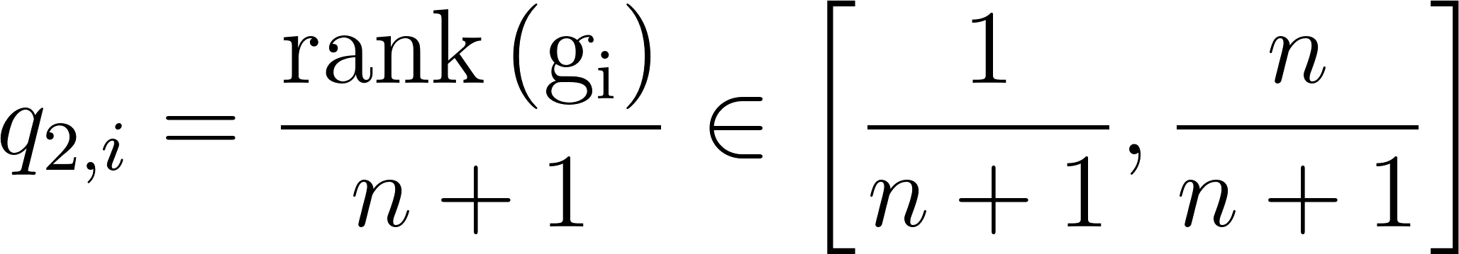

These normalized ranks are then quantile normalized (i.e., by applying the inverse cumulative distribution function of the normal distribution)

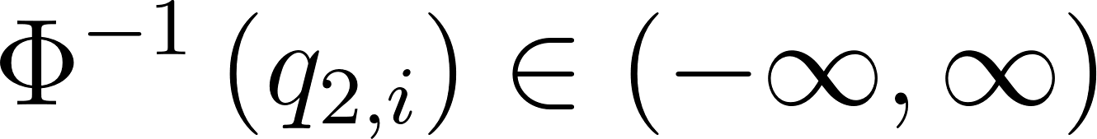,

weighted by the (signed) Mode of Regulation (MoR) of gene i, and finally summed

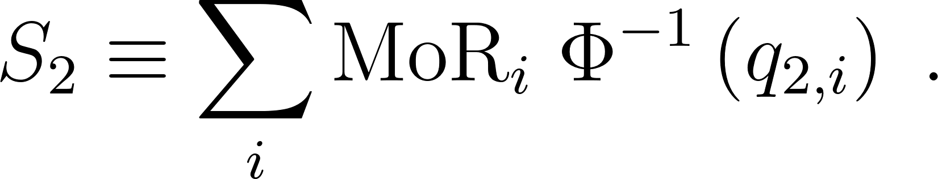
(Note that S₂ is, confusingly, referred to as sum1 in the source code.)

Recall that the MoR output by the GRN prediction method (and, hence, input to VIPER) should be between -1 and 1. This is enforced if necessary.

S₂ score receives positive contributions from both: 1) genes that are lowly expressed (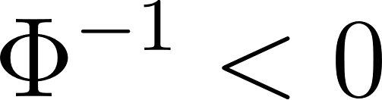) and repressed () since their product (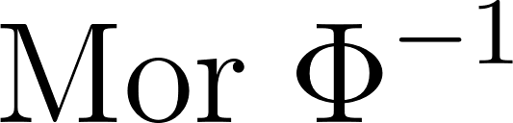) is positive and 2) genes that are highly expressed (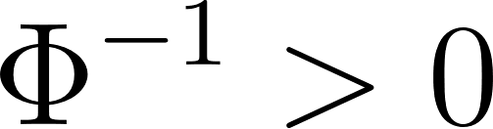) and induced () since their product () is also positive.

For the 1-tail test, genes at the extreme low and high ends of the expression spectrum are assigned high ranks, which are subsequently weighted by positive values. This results in the 1-tail test prioritizing genes at the extremes of the expression spectrum. The essence of the 1-tail test is the extreme-sensitive (normalize) ranking q_{1,i} of gene i, which “folds” the above q_{2,i} such that values near q_{2,i} = 0 or q_{2,i} = 1 have high q_{1,i} near 1, whereas intermediate values near q_{2,i} = 0.5 have low q_{1,i} near 0:

where

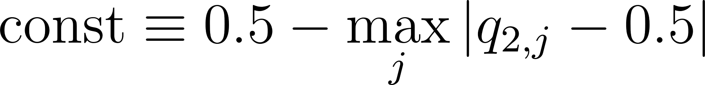

is a constant contributing a small, gene-independent shift. These q_{1,i} are then weighted by the positive 1 - | MoR_{i} | (since MoR_{i} is between -1 and 1) and summed

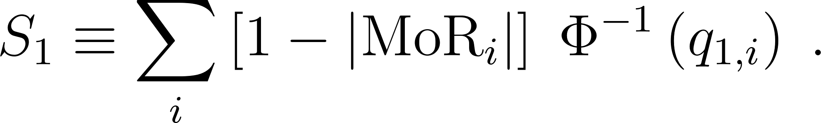
(Note that S₁ is, confusingly, referred to as sum2 in the source code.)

So, genes with extreme expression and strong predicted repression or induction will contribute to S₂ (positively, if the extreme expression is consistent with the direction of MoR and negatively, otherwise). Genes with moderate expression will not contribute to S₂. Genes with extreme expression and low predicted repression or induction will contribute positively to S₁. Genes with moderate expression and low repression/induction will negatively contribute to S₁.

These two sums are combined in the final 3-tail test score as

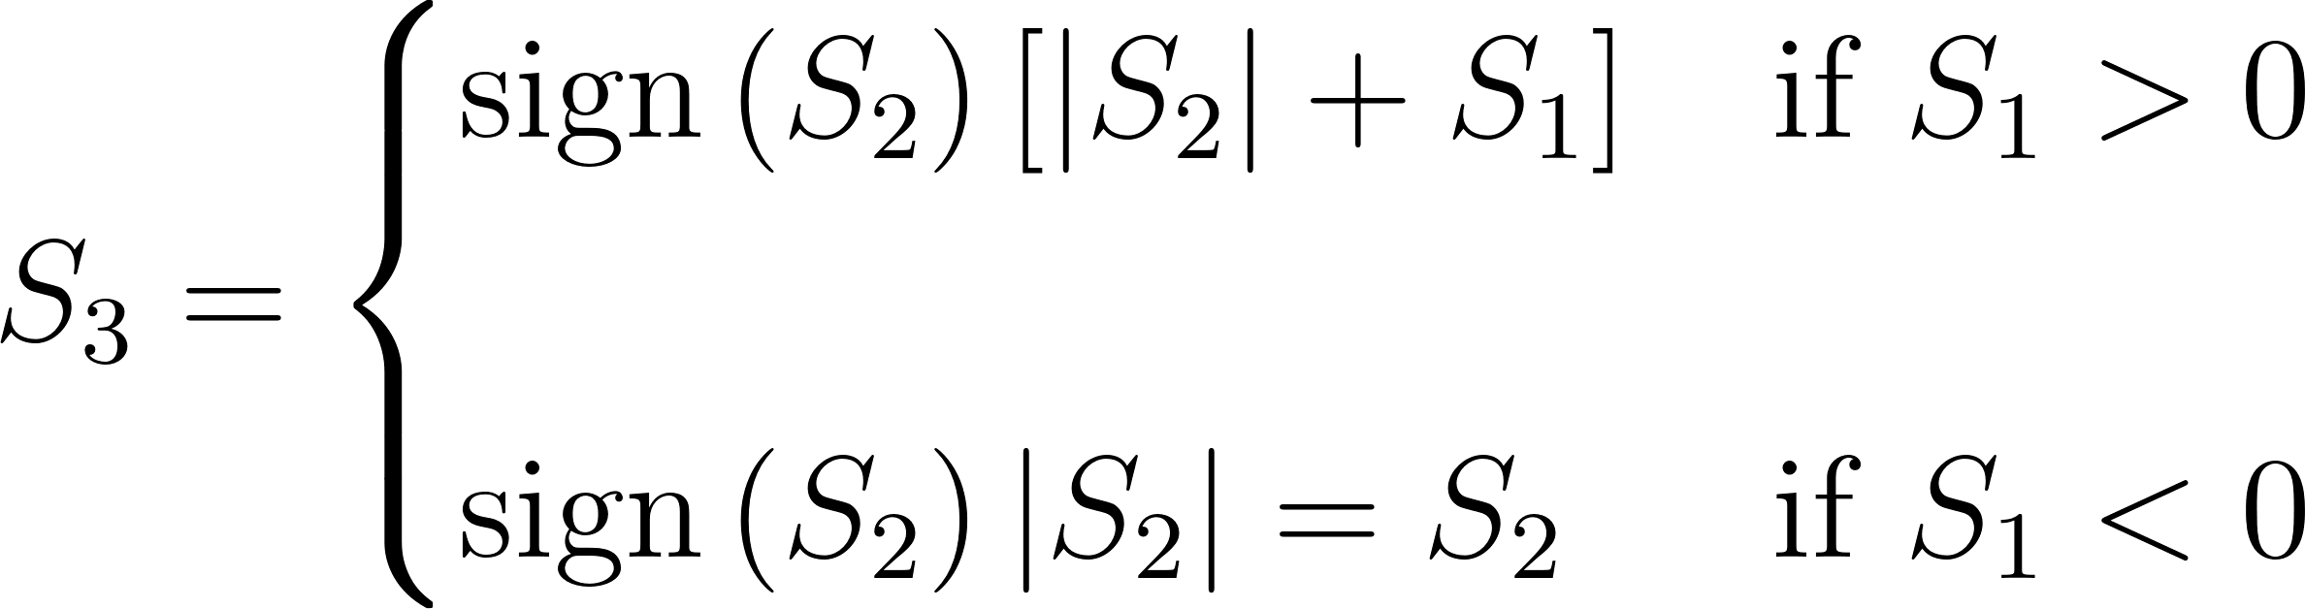

Code deliverable:
You should submit a function that outputs TF targets. This function should have the same signature as our score.viper function (in apply-viper-evaluation.R). In particular, note that it does not hardcore the cell type and perturbation columns, but rather has defaults (to celltype_jf and gRNA_perturb) that can be overridden. Your function should return a data.frame with the same columns as score.viper. In particular, each row corresponds to a cell. Columns indicate the cell’s type (cell.type), the TF whose score is reported, the perturbation to that cell (either the gene noted in the TF column or “none” for WT cells), and the condition of the reported TF (KO if perturbation is the TF or WT if perturbation is none). Scores will be evaluated independently for each cell type/TF pair. Within that pair, lower scores indicate less activity of the TF than higher scores. In that sense, the relative value of scores is important – their sign or absolute value is not relevant. You should report the activity of each TF for all WT cells and of each particular TF that is perturbed in a given cell.

Tasks and associated grades associated with this final project are listed below:
(2 points) Task 3: Discussion during class on March 2.
No slides are required. Bring any questions you have about the project to class.

(3 points) Task 4: Preliminary plan for analysis. Due March 5 @ 11:59pm.
Submit a plan for analysis, including a plan for division of labor. Maximum 1 page. Bullet points ok, but please write in complete sentences.

(10 points) Task 5: Presentation. Due March 13 @ 11:59pm.
Post your recorded presentation on Canvas Discussion Board. Your recorded presentation must be under 20 minutes, and include the division of labor.

(10 points) Task 6: Code and documentation. Due March 16 @ 11:59pm.

(15 points) Task 7: Group report. Due March 17 @ 11:59pm.

You can use existing bioinformatics resources (including GitHub) and software tools as long as you cite these resources. You are encouraged to explore Bioconductor packages not discussed in class. You can use either R or Python in this project. The use of generative AI is allowed as long as you cite the resource.
Not citing resources from the public domain constitutes academic misconduct and will be reported. Additional details for each task will be provided.

Learning objectives: You will acquire experience reading journal papers, hands-on experience analyzing published genomic data. You will also gain experience in giving scientific presentations, writing scientific reports and working as a team.

Relevant papers
To learn more about the goals of the MorPhiC consortium, you can check out the following marker paper:
Adli, M., Przybyla, L., Burdett, T. et al. MorPhiC Consortium: towards functional characterization of all human genes. Nature 638, 351–359 (2025). https://doi.org/10.1038/s41586-024-08243-w

Marbach, Daniel, et al. "Wisdom of crowds for robust gene network inference." Nature methods 9.8 (2012): 796-804.

Badia-i-Mompel, Pau, et al. "Gene regulatory network inference in the era of single-cell multi-omics." Nature Reviews Genetics 24.11 (2023): 739-754.

Moerman, Thomas, et al. "GRNBoost2 and Arboreto: efficient and scalable inference of gene regulatory networks." Bioinformatics 35.12 (2019): 2159-2161.
https://academic.oup.com/bioinformatics/article/35/12/2159/5184284

DETAILS ON FINAL REPORT
The report is expected to include the following sections: Title, Abstract, Introduction, Methods, Results and Discussion. There should be a Reference section which does not count towards the page limit. You can include any other files that you would like to submit as supporting information. One submission per team.

If your team is graded with the TCSS 588 rubric, you are expected to include a discussion of related work in the Introduction section, summarize and cite recent papers on scRNA-seq data analysis in the literature.

You can choose to write your report using any word processing tools, such as Word, Google Doc, Latex, Overleaf etc.

You are NOT required to use the following suggested templates, as long as your report contains all the required sections.

Example report templates available at https://www.acm.org/publications/authors/submissions, or https://academic.oup.com/DocumentLibrary/Bioinformatics/cabios_word_temp.zip

Final report Rubric for 478 students: 3-4 pages (out of 15 total points)
- (5 points) Quality and comprehensiveness of approach and results.
- (2 points) Description of work undertaken.
- (2 points) Clear description of results. Proper use of graphs, charts, tables in the description of results. Figures/tables have captions, and are clearly labeled.
- (2 points) Documentation of division of labor.
- (2 points) Clarity: The report is easy to read, and analysis flows.
- (2 points) Format: Report includes the required sections (Title, Abstract, Introduction, Methods, Results and Discussion). Include citations and references.

Final Report Rubric for 588 students: 4-6 pages (out of 15 total points)
- (5 points) Quality and comprehensiveness of approach and results.
- (3 points) Description of work undertaken: Data and approach are justified and described in detail, with easy-to-understand figures/tables. Citing and referencing the correct resources. Include summaries and citation of related work in the Introduction section.
- (2 points) Clear description of results, and thoughtful discussion to support the observations. Proper use of graphs, charts, tables in the description of results. Figures/tables have captions, and are clearly labeled.
- (2 points) Clarity: The report is easy to read, and analysis flows. Language is correct. Terms of analysis and description are clearly laid out and well-defined.
- (2 points) Format: Report includes the required sections (Title, Abstract, Introduction, Methods, Results and Discussion). The bibliography follows a recognized scholarly style. Citations are thorough and well documented throughout the paper.
- (1 point) Documentation of division of labor.

